A000-Eur-Czech Rep.-Petrkovice bei Ostrava, **Paleolithic Female Figurine-**20,790 BP

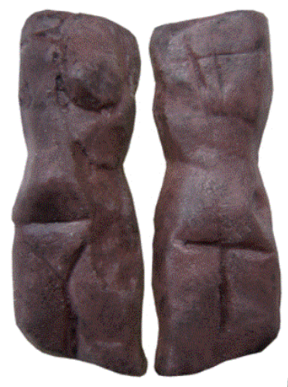 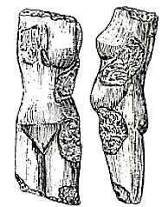

Fig. 1. UR 005 Tschechien Petrkovice Replica; Fig. 2. Drawing of orginal.

Cae No.: 1

**Formal Label: Czech Republic,** Petrkovice bei Ostrava, **Paleolithic Female Figurine 20,790 +/- 270 BP**

**Display Description:** This headless female figurine of mammoth ivory from the eastern Gravettian Culture is associated with open sites of specialized mammoth hunters on the plains of central Europe and Russia such as the derivative Pavlovian culture, in the region of Moravia, northern Austria, the Czech Republic and southern Poland ca 29,000 – 25,000 BP. The only aspect of the gender of this figurine is a depiction of the pubic “V”.

**Accession Number: A 142.**

**LC Classification:** GN772.2.A8.

**Date or Time Horizon:** 20,790 +/- 270 BP

**Geographical Area:** Czech Republic, Moravia, Petrkovice bei Ostrava, 49.88464, 18.280184

Map: <https://www.bing.com/maps/?v=2&cp=49.835556~18.2925&style=h&lvl=12&sp=Point.49.835556_18.2925_Ostrava___>

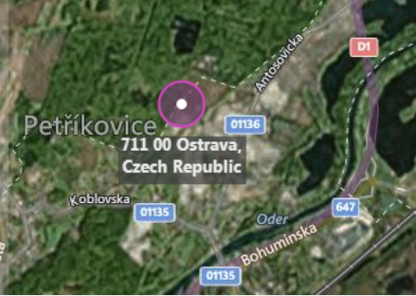

**Cultural Affiliation:** eastern Gravettian,

**Medium:** Hematite

**Dimensions: H 4.5 cm; W** 1.5 x 1.4 cm**.  
Weight: original, not known.**

**Provenance: original in the Anthropos Institut, Moravian Museum in Brno.**

**Condition:** museum replica in resin.

**Discussion:**

This hematite figurine was found within the current city limits of Ostrava (Ostrava-Petřkovice), Silesia, in the Czech Republic, by archaeologist Bohuslav Klíma on 14 July 1953. It was beneath a mammoth molar at an ancient settlement of mammoth hunters. Many stone artifacts and skeletal fragments were also found nearby. The absence of the head appears to be intentional, and, unlike other obese prehistoric Venus figurines, it shows a slender female, suggesting that its intentionality was personal and not as a fertility amulet.

The spatial analysis of this Moravian Gravettian landscape can be viewed on four levels (Svoboda 2003):

1. The Gravettian landscape (which differs from the Aurignacian or the Magdalenian landscapes) is related to the riverine network of Moravia, where sites and site-clusters are localized in the valleys, in lower altitudes, and in almost regular distances between each other.
2. The site-clusters (such as Dolní Věstonice-Pavlov) demonstrate an internal hierarchy, based on the size and the complexity of archaeological record.
3. The large sites are separated into individual settlement units (hearths, features, objects).
4. Dwelling structures are classified in four formal types; the hypothetical architectural constructions are tested against analogies from experimental archaeology and ethnoarchaeology.

As a result of this archaeological spatial analysis of the Moravian Gravettian landscape we may suggest that the hematite figurine was implanted in a low level riverine landscape, within a discrete, individual settlement of a larger site of mammoth hunters, within a dwelling structure of mammoth bones and tusks for support of mammoth hides, of which only the skeletal material was all that survived. It may be further hypothesized that hematite was chosen for its obvious weightiness as an object of worth to the sculptor, as there were many local sources of stone cobbles that could have served the purpose.

**References:**

Freeman, Leslie G., ed. 2011. *Views of the Past: Essays in Old World Prehistory and Paleanthropology,* Berlin: De Gruyter Mouton Publishers.

Klíma, Bohuslav. 1956. “Coal in the Ice Age: The Excavation of a Palaeolithic Settlement at Ostrava-Petřkovice in Silesia,” *Antiquity*, 30(118): 98-101

Svoboda, Jiří. 2003. “The Gravettian of Moravia: Landscape, settlement, and dwellings.” In S. A. Vasil’ev, O. Soffer, and J. Kpzlowski (eds.), *Perceived Landscapes and Built Environments*. British Archaeological Reports S1, London: Archaeopress, pp. 121-129.

Svoboda, Jiří, Ofer Bar-Yosef. 2003. *Stránská skála: origins of the Upper Paleolithic in the Brno Basin, Moravia, Czech Republic*. Cambridge, Mass.: Peabody Museum of Archaeology and Ethnology, Harvard University.

